Electric Vehicle Market Performance & Insights
Submitted by: Manas Jain
Team ID: N/A – Individual Project
Dataset Source: ev_market_train.csv
Tools Used: Tableau Public
Submission Date: 24 October 2026
1. Introduction
1.1 Project Overview
Electric Vehicle Market Performance & Insights is a data analysis project that explores electric vehicle market data. The project uses an interactive Tableau dashboard to present market information through charts, key metrics, and filters. It helps users explore the data and identify patterns across the years, regions, vehicle categories, or manufacturers included in the dataset.
1.2 Purpose
The purpose of this project is to make electric vehicle market data easier to explore and understand. The dashboard presents the available data in a visual format so users can compare categories and observe trends. The analysis is limited to the fields and time period available in the selected dataset.
2. Ideation Phase
2.1 Problem Statement
PS-1: I am an EV market researcher trying to understand how electric vehicle adoption changes over time. However, it can be difficult to identify important trends by reviewing raw records. This makes it harder to interpret market performance quickly.
PS-2: I am a person interested in the EV market trying to compare the available regions and vehicle categories. However, the information may be difficult to compare when it is not presented in one clear view. This can make it harder to draw conclusions from the data.
2.2 Empathy Map Canvas
Says: “I want to understand how the EV market is changing.” “I need to compare the categories available in the data.”
Thinks: “Which trends are most noticeable?” “Can I compare the data clearly?”
Does: Searches for EV market information and uses charts or filters to explore the available data.
Feels: May feel overwhelmed when reviewing many records, but more confident when the information is presented clearly.
Pains: Raw data can take time to review. Comparing trends and categories may be difficult without visual summaries.
Needs / Gains: A clear overview of the available EV market data, with charts and filters that make comparisons easier.
2.3 Brainstorming
The project ideas considered were:
- Show the year-wise trend in EV market data.
- Compare EV data across the regions included in the dataset.
- Show the distribution of the vehicle categories included in the dataset.
- Compare manufacturers, if manufacturer data is available.
The selected ideas were based on their relevance to the project and whether the required data was available.
3. Requirement Analysis
3.1 Customer Journey Map
The user begins with a question about EV market performance. The user opens the Tableau dashboard and reviews the overview. The user then selects available filters and compares charts or categories. Finally, the user reviews the visual results and uses them to understand patterns in the dataset.
3.2 Solution Requirements
Functional requirements
- The solution should display the EV data available in the selected dataset.
- The dashboard should present relevant metrics and visualizations.
- Users should be able to explore the data using the filters included in the dashboard.
- Charts should update appropriately when a filter is selected.
- The solution should show the selected dataset’s time period and categories clearly.
Non-functional requirements
- The dashboard should be easy to read and navigate.
- Labels, titles, and chart formats should be clear.
- The dashboard should display results consistently.
- The project should identify its dataset source and scope.
3.3 Data Flow Diagram
Insert the EV Project DFD diagram here. It shows how data flows from the EV dataset through data preparation and Tableau to the dashboard user. Adjust the diagram labels if your actual workflow differs.
3.4 Technology Stack
Component | Technology Used | Purpose
Data source | [CSV/Excel and dataset name] | Provides the EV market data for analysis
Data preparation | [Tool actually used, or “No separate preparation tool used”] | Used to review or prepare the data, if applicable
Data visualization | Tableau [Desktop/Public] | Used to create charts and the interactive dashboard
Project documentation | Microsoft Word / PDF | Used to prepare the project report
4. Project Design
4.1 Problem–Solution Fit
The project addresses the difficulty of exploring EV market information in raw data form. The Tableau dashboard presents the available information visually and allows users to compare the categories represented in the dataset. This makes the data easier to review and interpret.
4.2 Proposed Solution
The proposed solution is an interactive Tableau dashboard for exploring the selected EV dataset. It includes visualizations for the fields available in the data and provides filters where applicable. The dashboard is intended to help users review key figures and identify patterns in the dataset.
4.3 Solution Architecture
The project workflow is:
EV dataset → [Data preparation, if performed] → Tableau data source/workbook → Tableau dashboard → User
The dataset is used as the source for the analysis. Tableau connects to the data and displays the resulting visualizations in a dashboard.
5. Project Planning & Scheduling
5.1 Project Planning
Task | Description | Status
Review the dataset | Identify the source, fields, and time period | [Completed / In progress]
Prepare the data | Check and prepare the data using [tool, if applicable] | [Completed / In progress / Not applicable]
Define analysis questions | Select questions that can be answered using the available data | [Completed / In progress]
Create visualizations | Build charts in Tableau | [Completed / In progress]
Build the dashboard | Arrange charts and add available filters | [Completed / In progress]
Review the results | Check that the dashboard displays the data as expected | [Completed / In progress]
Prepare the report | Add documentation, screenshots, and project links | [Completed / In progress]
6. Functional and Performance Testing
6.1 Performance Testing
The dashboard was reviewed to confirm that its charts display the selected EV data and that the available filters work as expected. The visualizations were checked against the fields and values in the dataset.
Checks performed:
- Dataset fields used in the dashboard were reviewed: [Add result].
- Dashboard charts were checked for appropriate titles and labels: [Add result].
- Available filters were tested
- Chart values were compared with the source data
7. Results
7.1 Output Screenshots
Figure 1: Tableau Dashboard Overview
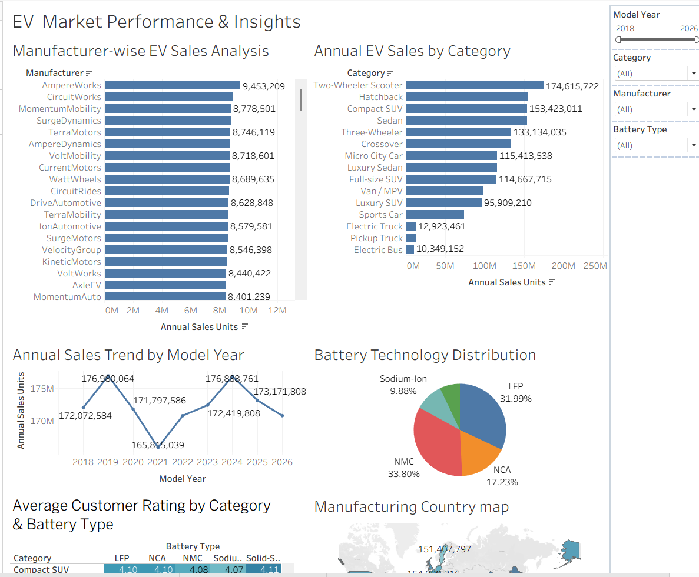
Figure 2: Annual Sales Trend
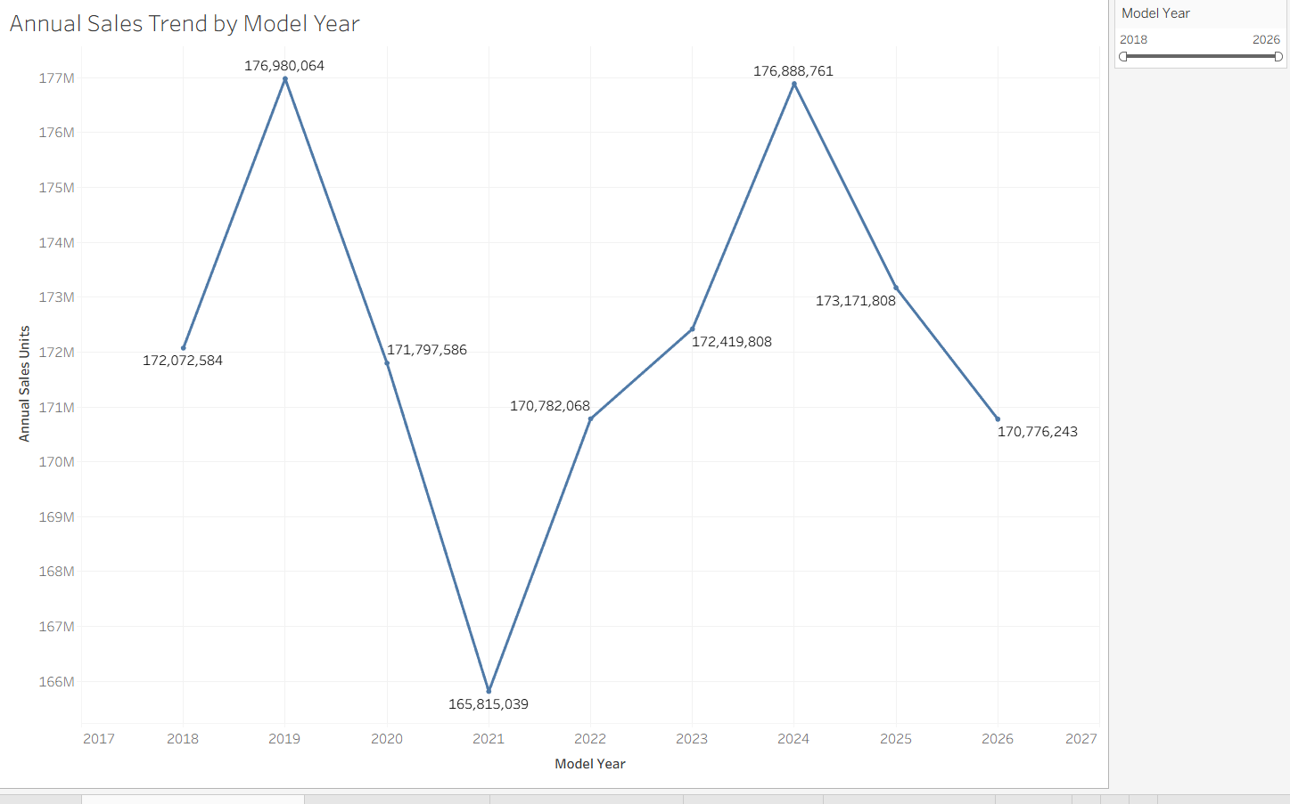
Figure 3: Battery Type Share
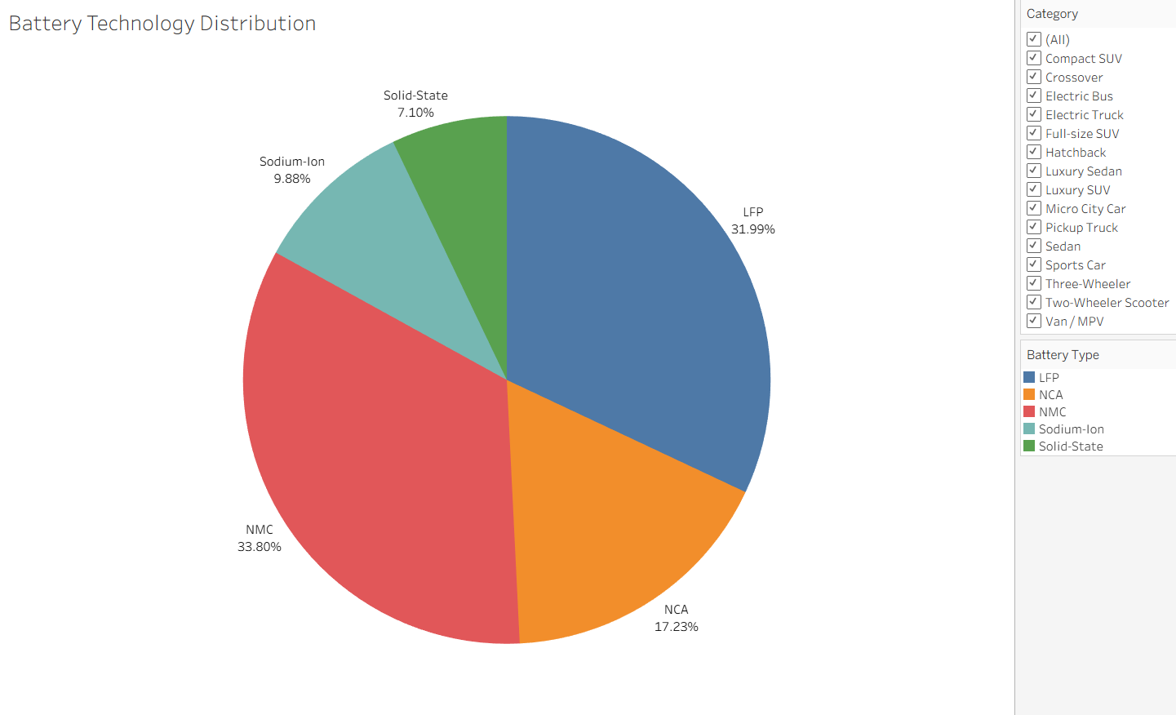
8. Advantages & Disadvantages
Advantages
- The dashboard presents the selected EV data visually.
- Charts make it easier to compare the categories included in the dataset.
- Available filters help users explore selected parts of the data.
- The dashboard brings multiple visualizations together in one place.
Limitations
- The analysis is limited to the information available in the selected dataset.
- The results may not represent the entire EV market if the dataset covers only certain years, locations, or categories.
- The dashboard reflects the dataset used when the project was created and may not include live updates.
9. Conclusion
This project uses Tableau to explore the electric vehicle market data available in the selected dataset. The dashboard presents the data through visualizations and, where available, interactive filters. It provides a convenient way to review the included categories and identify patterns. The findings should be interpreted within the scope and limitations of the dataset.
10. Future Scope
The project could be extended by adding newer data, additional regions, or more EV-related measures if reliable data becomes available. The dashboard could also include additional comparisons and updated filters. These are possible future improvements and are not part of the current project unless they have already been implemented.
11. Appendix
- Dataset source: ev_market_train.csv (provided dataset)
- GitHub repository: manasjain0509/EV-Market_Performance_Insights
- Tableau Public dashboard: https://public.tableau.com/app/profile/manas.jain4659/viz/EVMarketPerformanceandInsights/Story1?publish=yes
- Tableau Public story: published

